CIWRC NEWS
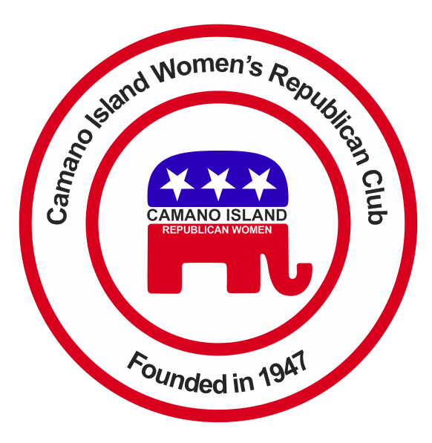
December 2016
Contact: Cindy Stulken 940-230-1525 E-Mail: cstulken@hotmail.com
NEXT MEETING: Tuesday, January 24, at Noon
Place: Lost Lake Clubhouse, 1469 Lake Drive Camano Island

December Christmas Lunch  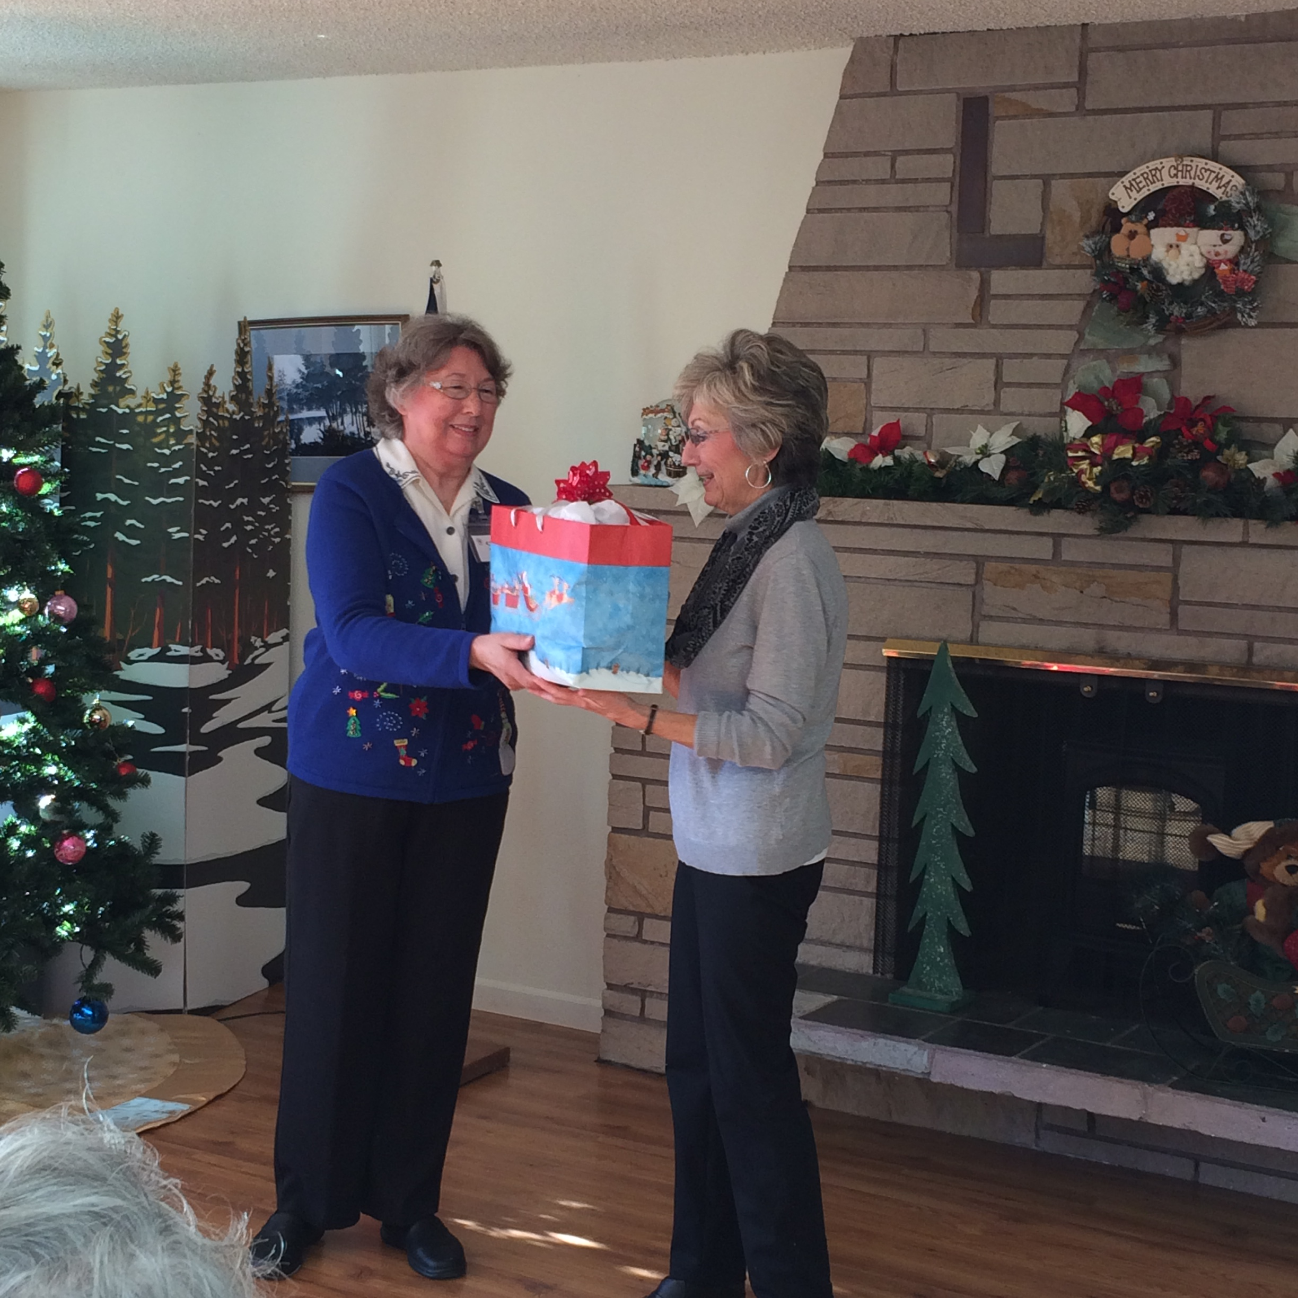  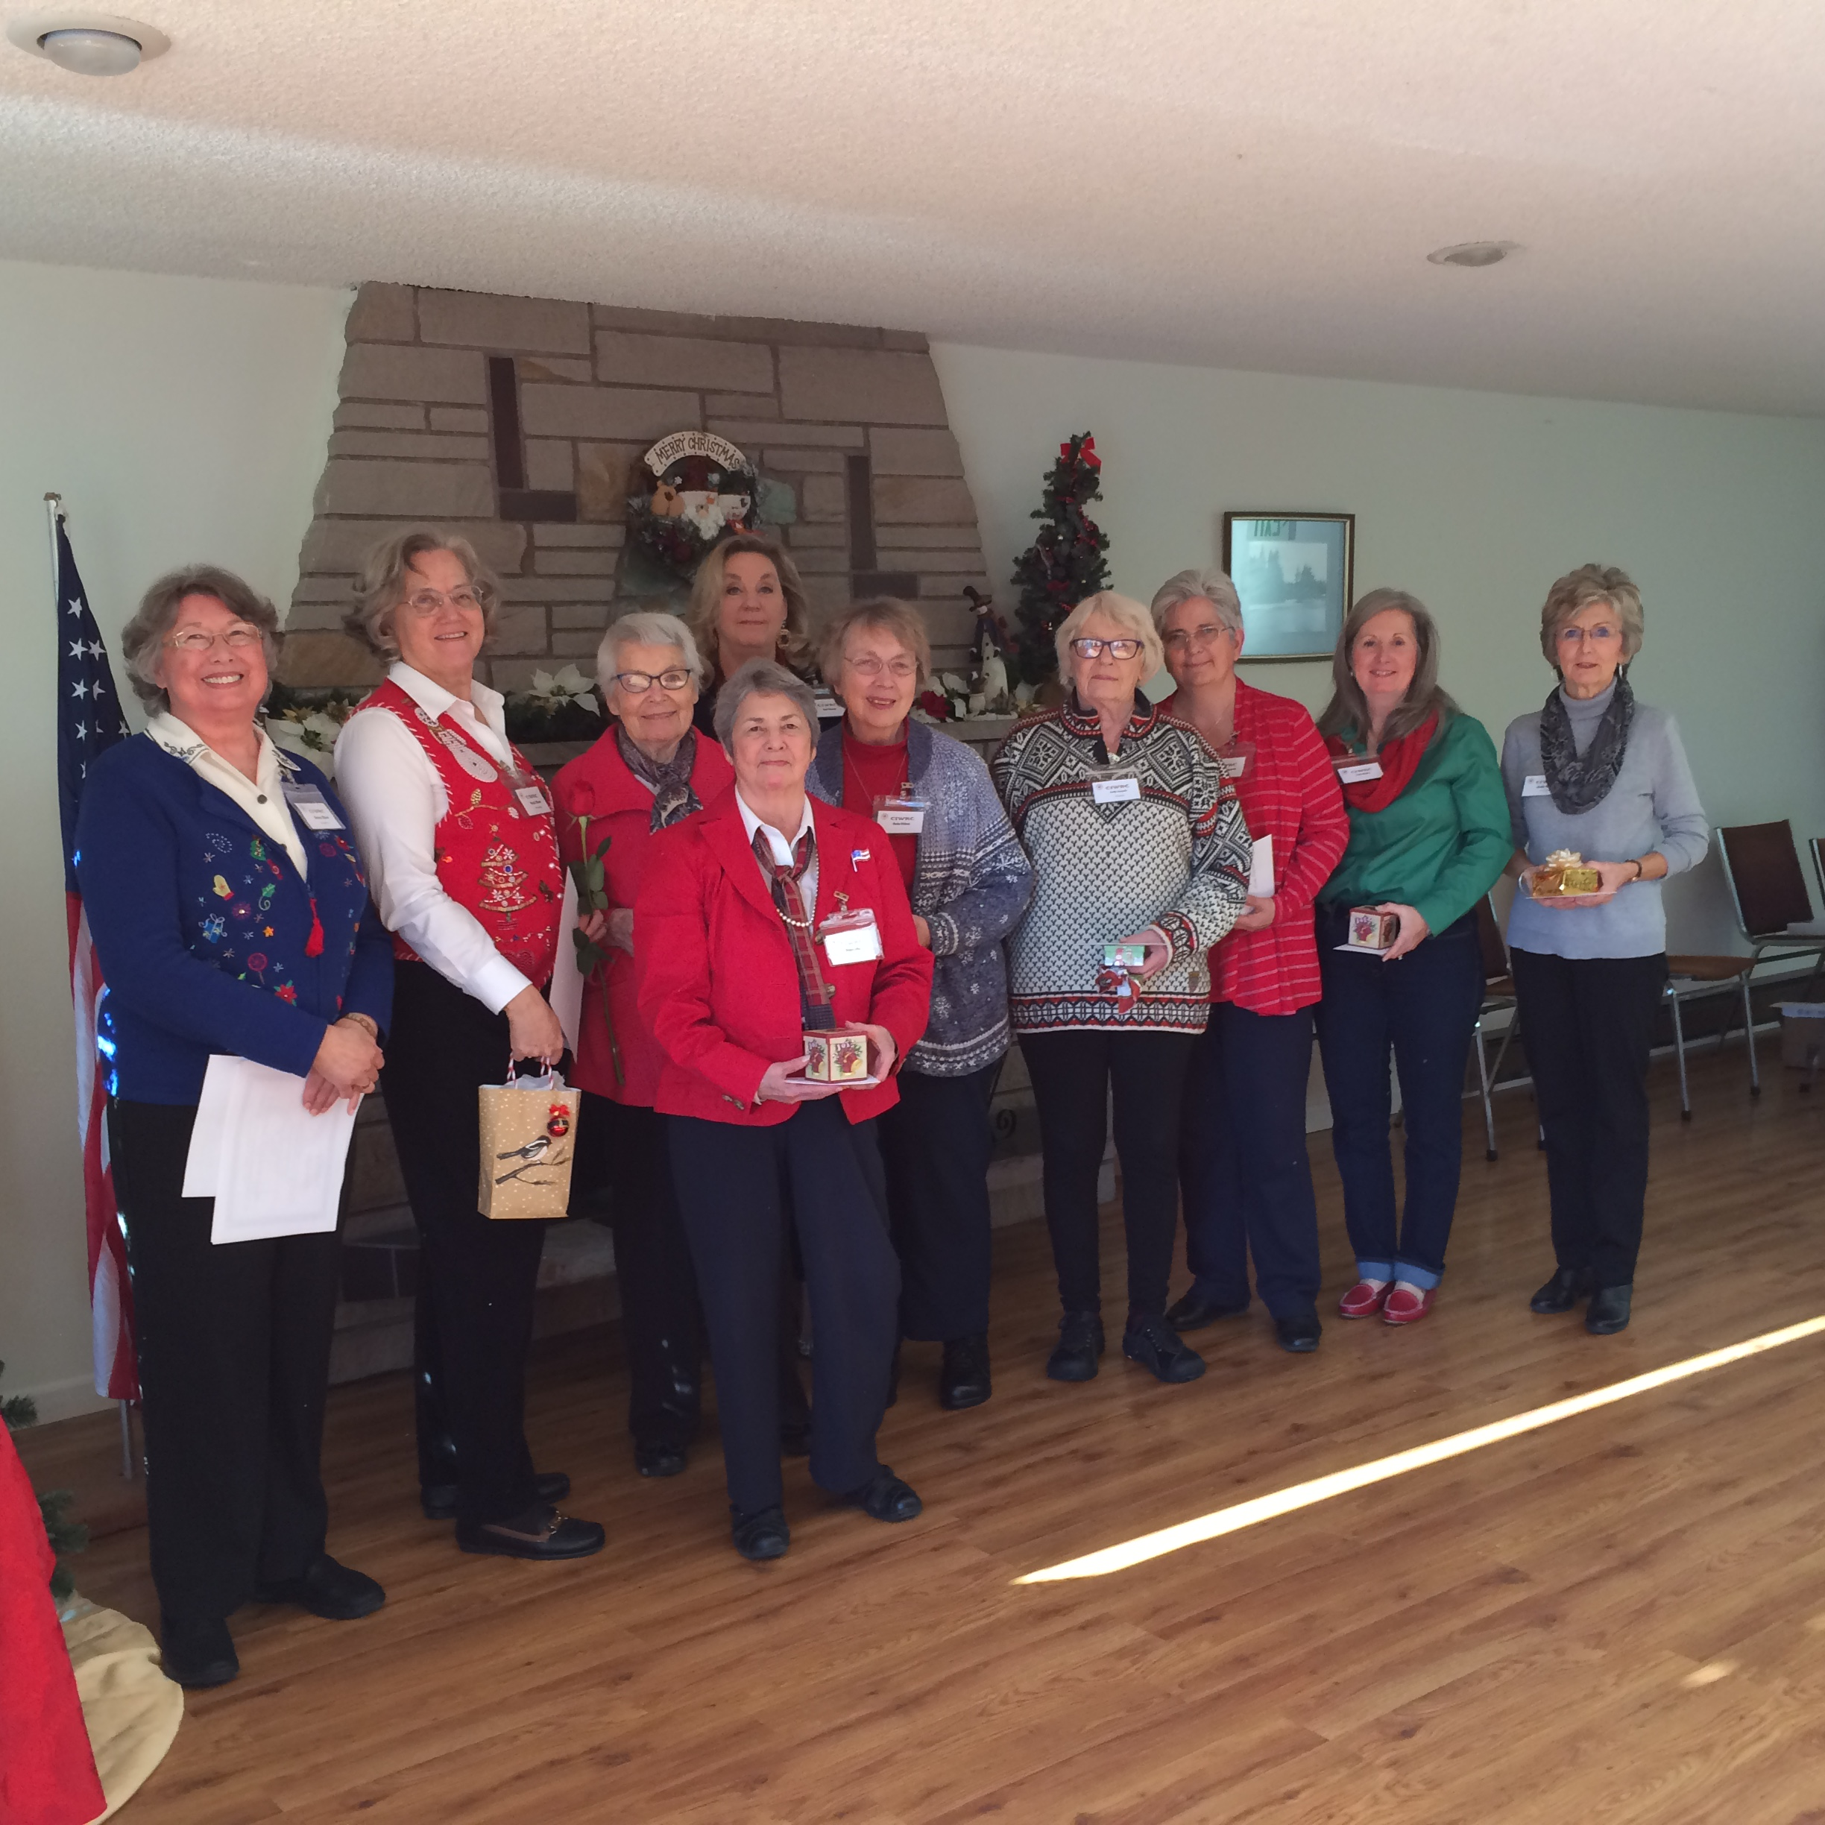  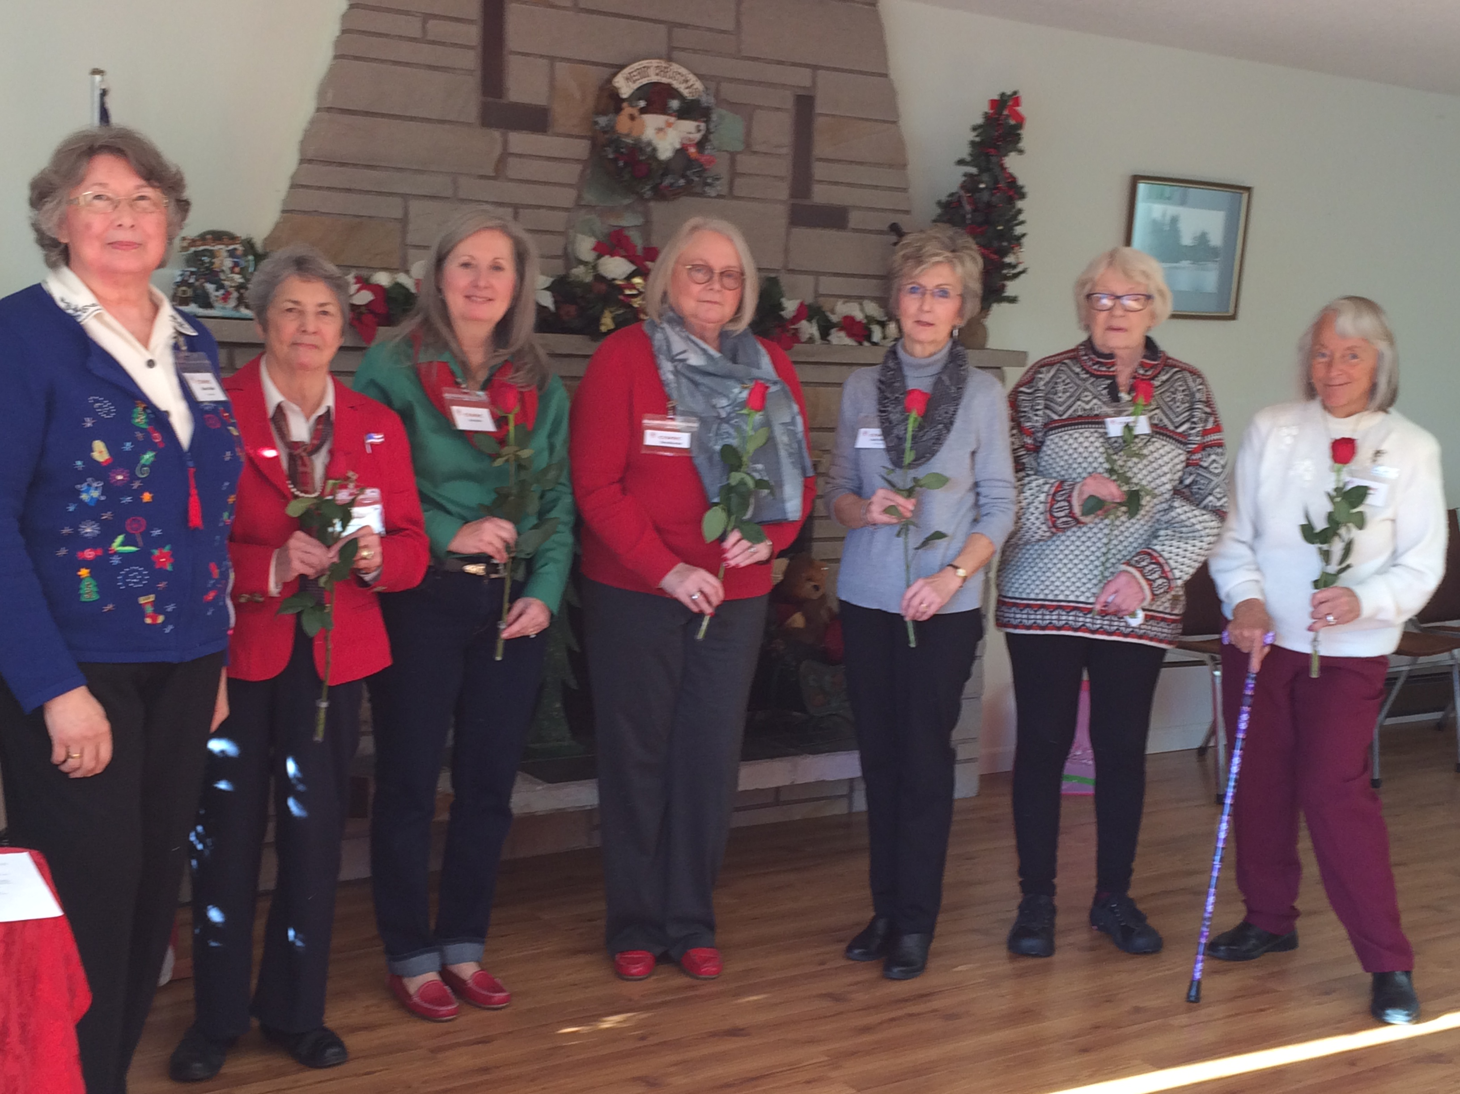  Thank You to the outgoing officers, you’ve done a fantastic job! | Jan 18 Rally on the Capital steps in Olympia  Convention of States:  Conventionofstates.com  Article V of the US Constitution allows citizens to call a convention to restrict the power and jurisdiction of the federal government and return the country to its original vision of a limited federal government that is of, by and for the people.  Let’s take a group!  Please invite a friend to join CIWRC & Help grow our membership! | UPCOMING EVENTS  2017  1/10 – Board Meeting  1/18 – Convention of State in Olympia  1/20 – Presidential Inauguration  1/24 – CIWRC meeting – Pay Annual Dues for 2017  Check it out –www.ciwrc.com  For Republican news, events, & candidate info:  www.islandcountygop.com  www.wsrp.org
Officers: President –Barbara Vibbert; Vice-President –Paula Deter; Secretary –Lesley Bentley; Treasurer – Linda Navarre; Trustee – Sally Sample; Trustee – Linda Hoggarth

