CIWRC NEWS
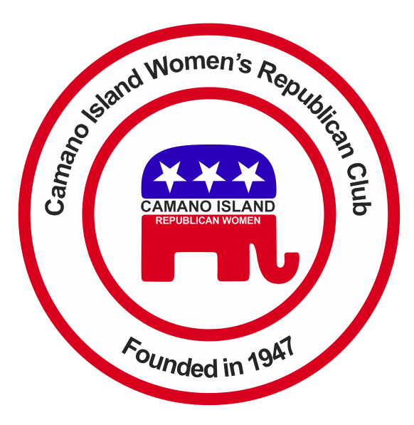
NOVEMBER –DECEMBER 2015
Contact: Barbara Vibbert 360-629-0399 E-mail: jabvibbert@gmail.com
NEXT MEETING: Tuesday, December 8, 2015 at Noon
PLACE: Lost Lake Clubhouse, 1469 Lake Drive, Camano Island, WA 98282
PROGRAM: CHRISTMAS PARTY
WFRW FALL CONFERENCE  Several CIWRC members, including President Barbara Vibbert, Lesley Bentley, Cindy Stulken, and Larry Bentley attended the 2015 Fall Board Meeting and Conference at the Doubletree Suites, in Tukwila, WA November 13-14. They attended leadership workshops on Friday and Lesley, as Barbara’s proxy on Saturday, accepted the NFRW SILVER AWARD for the Club at the Presidents’ Meeting. She also joined the WFRW Winner’s Circle! CONGRATULATIONS and THANK YOU to everyone who contributed so much to make these past two years such a resounding success. You can be proud of your accomplishments!  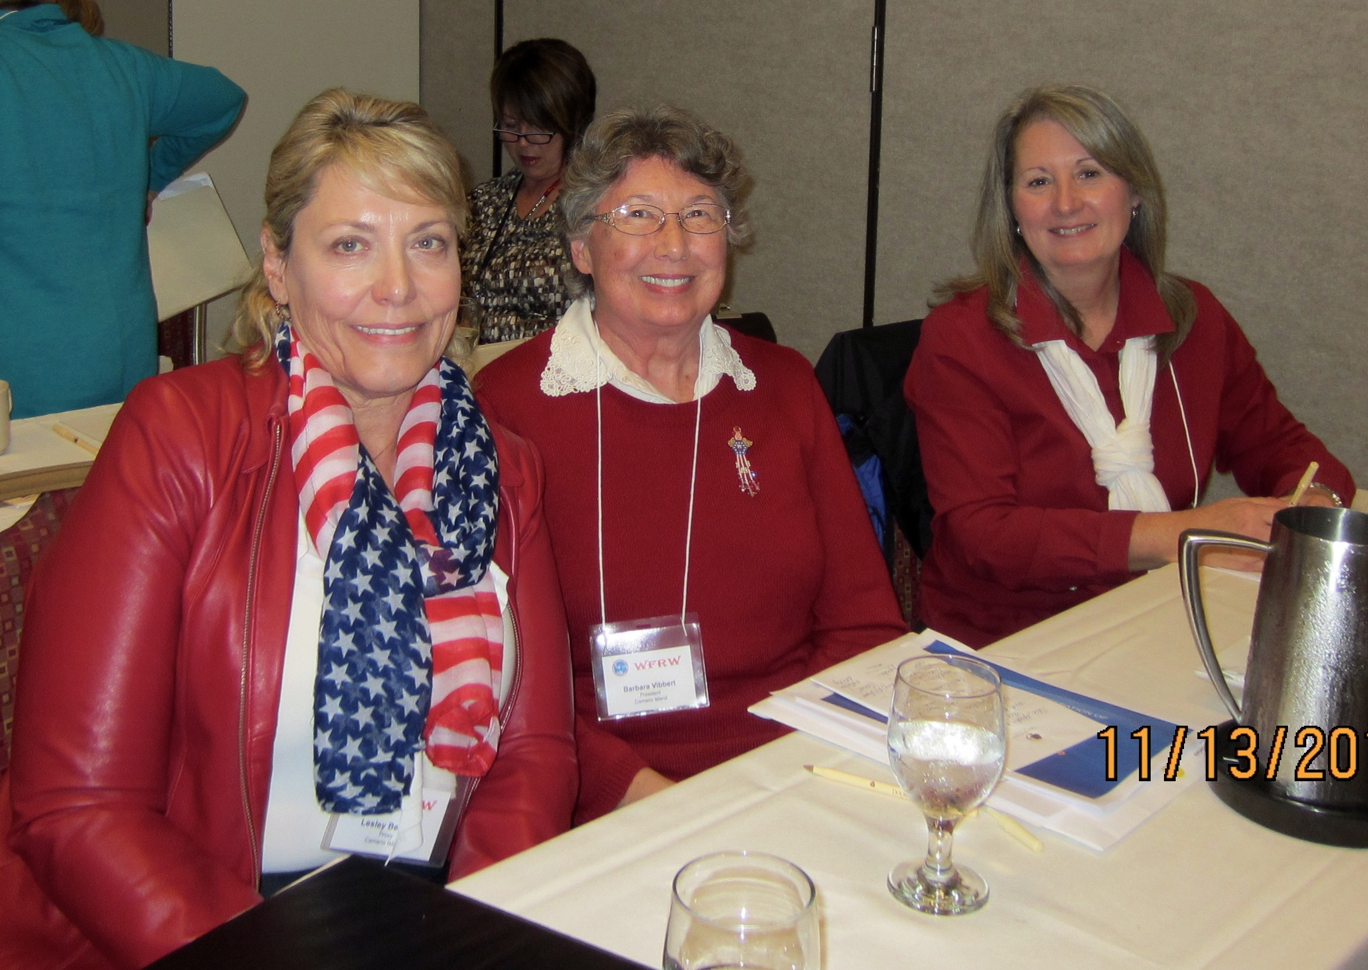 | ** CHRISTMAS PARTY **  December 8  The CIWRC Board will host the luncheon and everyone will have an opportunity to fill food bank bags for the Stanwood-Camano Community - made possible by your generous donations.  We’ll have several special guests including District Director, Jeanne Quinlivan who will install our newly elected officers and WFRW President, Roxanne Husmann who will present the NFRW Award. Expect fabulous food and lively music by Camano violinist, Walt Werme and company!  DON’T FORGET TO BRING YOUR SIGNED CHRISTMAS CARDS FOR VETS TO GIVE TO PAULA DETER FOR DELIVERY.  Bring a guest – invite her to join. We have an exciting agenda for 2016 – an election year, a fun trip to Olympia for WFRW Day at the Capitol in February, and more!!  MERRY CHRISTMAS  TO YOU ALL !!! | NOVEMBER HOLIDAY BAZAAR  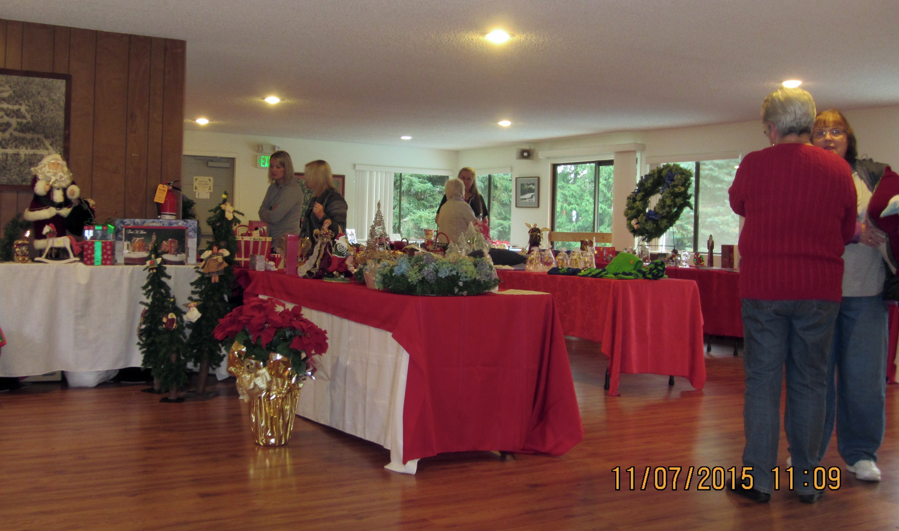  Linda Navarre and her creative volunteers took in $880 in sales from baked goods, Christmas items, and hand decorated wreaths at the Lost Lake Clubhouse. Despite the weather there was a good turnout. A big thank you to all who donated goods, time, and muscle to make this another successful fundraiser!!  FYI - In 2016 CIWRC will be part of WFRW Snohomish District which will include Camano Island, Evergreen and Snohomish Clubs.  CIWRC WEBSITE  Check it out –www.ciwrc.com  HAPPY THANKSGIVING!!

Officers: President –Barbara Vibbert; Vice-President –Evelyn Biehl; Secretary –Paula Deter; Treasurer – Linda Navarre; Trustee – Sally Sample; Trustee – Linda Hoggarth

