CIWRC NEWS
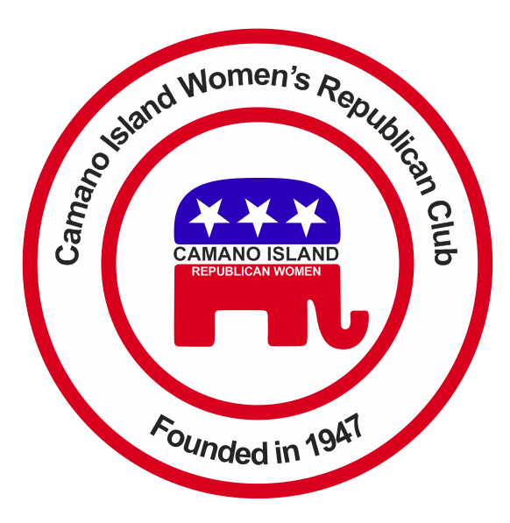
September 2022
Contact: Barbara Vibbert 360-631-3953 E-mail: jabvibbert@gmail.com
NEXT MEETING: Tuesday, September 27, 2022 at Noon
PLACE: Lost Lake Clubhouse, 1469 Lake Drive, Camano Island, WA 98282
Program: Club Business
SUMMER ACRIVITIES  Stanwood Parade  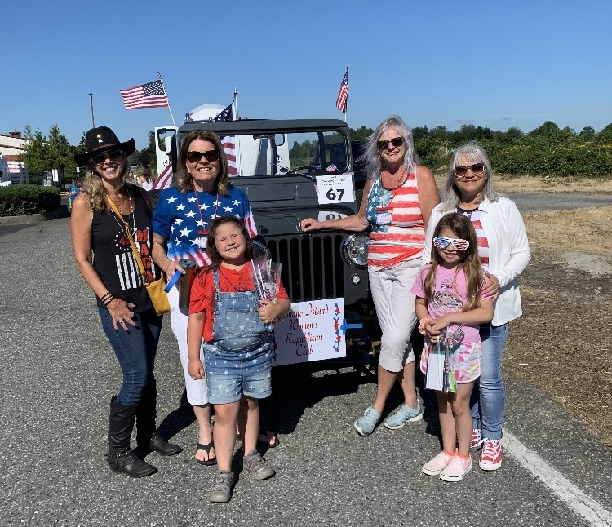  Participants included Angie & Mike Wrzesinski, Wendi & Lance Monnie, Charlene White & Husband, Tracy Abuhl, Grandkids, Tim Hazelo  Stanwood Camano Fair Booth  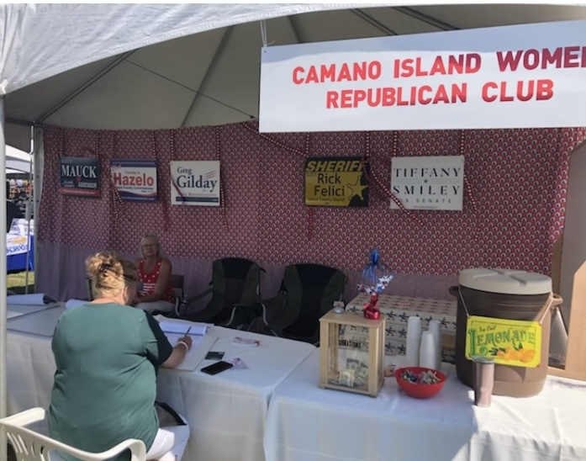  Beth Munson set up the booth again this year. Candidates Tim Hazelo and Kelly Mauk volunteered to work along with several CIWRC members.  ******************************VOLUNTEER HOURS  Don’t forget to document any hours you worked on Club Campaign or Caring for America activities. Send your hours to Linda Navarre for July-December 2022. Hours must be reported to NFRW by January 2023.  THANK YOU for being a CIWRC member!  About ERIC  The Electronic Registration Information Center (ERIC) is advertised as a voter roll maintenance system. As such, it must serve each state in keeping their voter registration lists current, and purged of invalid and ineligible voters. ERIC charges membership fees to do so. 31 states have joined the group, and pay well for this service. Here is the current list of states who are members of ERIC: AL, AK, AZ, CO, CT, DE, FL, GA, IL, IA, KY, LA, ME, MD, MI, MN, MO, NV, NM, OH, OR, PA, RI, SC, TX, UT, VT, VA, WA, DC, WV, and WI.  A list of the 2020 voter registration numbers for the ERIC member states, expressed as total voter registration/total citizen voting age population, is shown on the column to the right.  More Info: online article by Jim Hoft (thegatewaypundit.com) published January 20, 2022. Google: Who’s “Cleaning” Our Voter Rolls? Soros Founded and Funded ERIC is Now Used in 31 States. | UPCOMING EVENTS  Tuesday, September 27  LUNCH  Our hostess this month is Sheila Cramer. Please RSVP by FRIDAY, September 23  to our Hospitality Chair  LINDA NAVARRE at  360-387-5886/253-632-9185  E-mail: crab.e.mike@gmail.com  ****************************CICIWRC ELECTION OF OFFICERS  It’s that time of year again when we all must think about how we can best serve to meet our Club objectives. If you are willing and able to serve as a Club Officer, please give your name to the Nominating Committee which will be elected at the September meeting by a majority of members present and voting at that meeting. The committee will be asking for candidates to present for election at the October meeting.  ******************************  CLUB FOCUS  On the Agenda for September:  Stanwood Camano Fair  Caring for America  Parade  GOP Headquarters Stanwood  Nominating Committee for  2023 Officers  Meeting Times  2023 Fundraisers  Poll Watching & Election Integrity  ******************************  STANDING COMMITTEES  Budget & Finance/Membership – Angie Wrzesinski  Bylaws - Virginia Collins and Barbara Vibbert  Campaign - Beth Munson  Fundraising – Executive Committee  Legislative – Wendie Monnie  Program – Executive Committee  Public Relations – Beth Munson  Caring for America – Nancy Bowman  Hospitality – Linda Navarre  Literacy and Education – Pat Shaughnessy  Sunshine – Pam Wojtowicz  ABOUT ERIC Continued:  Fifteen (50%) of the ERIC states, as highlighted, have voter rolls containing more registrations than their citizen voting age populations.  AL: 100.9% MO: 94.2%  AK: 121.7% NV: 101%  AZ: 96.1% NM: 90.9%  CO: 103.6% OH: 91.5%  CT: 96.9% OR: 96.4%  DE: 104.1% PA: 92.4%  FL: 101.6% RI: 102.0%  GA: 103.6% SC: 101.8%  IL: 108.2% IA: 96.7% TX: 93.3% UT: 91.8%  KY: 106.5% VT: 98.7%  LA: 89.4% VA: 97.3%  ME: 106.9% WA: 100%  MD: 100.4% WV: 88.5%  MI: 108.1% WI: 87.8%  MN: 91.7% District: n/a  These numbers were taken from the U.S. Election Assistance Commission website, 2020. | CIWRC always welcomes  NEW MEMBERS  Bring a friend or relative to the next meeting or event and encourage them to join us.  MEMBER SPOTLIGHT  Get to Know Your  CLUB SECRETARY  Wendi and her husband, Lance have been happily married for 35 years. They lived in Bothell and raised two sons, Casey and Jory there. They are blessed to have 4 grandchildren ranging in age from 1 to 15 who keep them very busy. Wendi worked as a Manager of a Dental office for 32 years and retired in 2016 to be a full time Grandma! In July 2019, after 32 years in Bothell, they moved to Camano Island. She and Lance love their lives on the island. While Lance collects and builds classic cars, Wendi collects rescue dogs – currently Bonnie and Clyde. She joined CIWRC in September of 2020, which was an answer to her prayers for God to give her something to do to help save our Country. She absolutely loves our club and all of you who are fighting to save this Country for our kids and grandkids.  *************************  ISLAND COUNTY GOP CENTRAL COMMITTEE MEETING – at Deer Lagoon Grange in Langley on September 10 at 10 a.m.  ISLAND COUNTY REPUBLICAN MEETING - October 1  Locations can be found at www.IslandCountyGOP.com  ***************************  CIWRC Facebook group:  https//www.facebook.com/  groups/341414871432700  **************************  VOLUNTEER AT GOP HQ Stanwood Office  Contact Beth Munson at 425-387-1277 or e-mail:  Beth.m@1791.com  You can also sign-up to work at the HQ on the  CIWRC WEBSITE  Check it out –www.ciwrc.com  NEWSLETTER  Any news items you wish to include in the newsletter should be submitted to Barbara Vibbert by the 15th of each month prior to the regular meeting.
2022 Officers: President –Tracy Abuhl; Vice-President –Beth Munson; Secretary –Wendi Monnie; Treasurer – Angie Wrzesinki; Trustee – Linda Navarre; Trustee – Nancy Bowman

