CIWRC NEWS
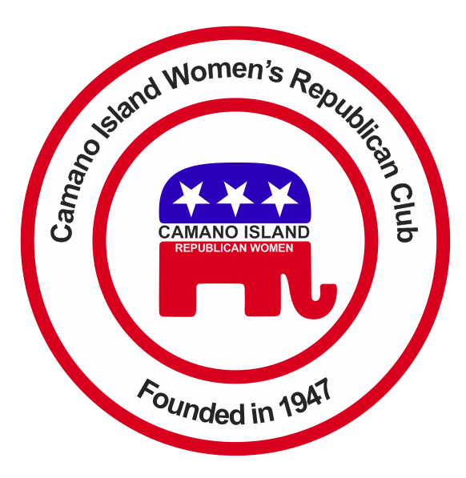
JUNE 2015
Contact: Barbara Vibbert 360-629-0399 E-mail: jabvibbert@gmail.com
NEXT MEETING: Tuesday, June 23 at Noon
PLACE: Camano Country Club Beach #2
PROGRAM: Potluck Picnic & Rally at the Beach – Speaker Rep. Dave Hayes
Contender for Congress!!  State Rep. Elizabeth Scott filed paperwork May 21 with the Federal Election Commission to run against incumbent US Rep. Susan DelBene, a social liberal and fiscal moderate. Some of their differences - Scott is a tea party favorite who opposes legal abortion and gay marriage while heavily funded Democrat Del Bene supports both. Scott voted against raising the minimum wage in WA state while DelBene wants to hike the federal minimum wage.  Watch for more about Scott in coming months.  ** Up For Election in 2016 **  Our State has been in the hands of Democrats too long – so get ready to change these D’s to R’s!!  2nd Congressional District – Rick Larsen (D)  US Senate – Patty Murray (D)  Statewide:  Governor Jay Inslee (D)  LT. Gov. Brad Owen (D)  Sec. of State Kim Wyman (R)  10th Legislative District – Sen. Barbara Bailey (R)  Island County – Commissioner District 1 – Helen Price Johnson (D) | Coming Events  POTLUCK PICNIC  & RALLY AT THE BEACH  Join us for food and fun at Camano Country Club Beach #2 from noon – 3 p.m. on Tuesday, June 23. Bring a potluck dish – pulled pork sandwiches, hotdogs, chocolate cake, homemade ice cream and drinks will be provided. Guest speaker Rep. Dave Hayes will be there to speak on I-594 (gun control) and current issues of interest to Camano Islanders. Call Linda Navarre for more info or if you wish to donate an item for the raffle – 360-387-5886.  I-5 RESTSTOP COFFEE STAND  There are still openings for volunteers to staff the booth at the I-5 Northbound rest stop. Need teams for July 8 (6 p.m.-10 p.m.) July 9 (2 a.m.-6 a.m.; 6 a.m.-10 a.m. and 10 p.m.-2 a.m.). Cans of coffee and at least 5 dozen cookies (homemade acceptable) per shift would be appreciated. Contact Jacie DeGroot for more info at 425-231-0606 or e-mail: jaciedegroot@aol.com | 4TH OF JULY PARADE  Be sure to join Paula Deter for the Saturday, July 4 Parade in Stanwood again this year. Ride in her trusty truck or walk the route handing out flags. Meet at Josephine Sunset Home 9901 272nd Pl, Stanwood. Parade usually starts at 11 a.m.  More Upcoming Events and photos are available on the  CIWRC WEBSITE  Check it out – www.ciwrc.com  PHOTOS FOR HISTORIAN  If you have any photos or items for the CIWRC scrapbook please share them with Linda Hoggarth, Club Historian. Bring them to the CIWRC meetings or give her a call at 425-344-7419.  NO TAX INCREASE NEEDED  According to the latest WA State Economic & Revenue Forecast Council the State will have about $3.2 billion in revenue for the 2015-17 budget cycle – a 9% increase in projections!

Officers: President –Barbara Vibbert; Vice-President –Evelyn Biehl; Secretary –Paula Deter; Treasurer – Linda Navarre; Trustee – Sally Sample; Trustee – Linda Hoggarth

