CIWRC NEWS
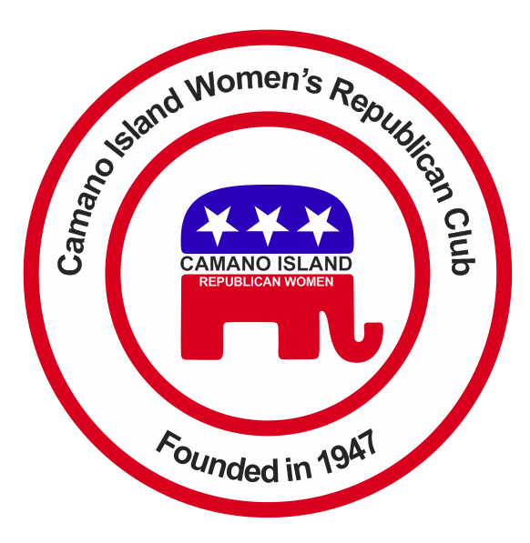
January 2017
Contact: Cindy Stulken 940-230-1525 E-Mail: cstulken@hotmail.com
NEXT MEETING: Tuesday, January 24, at Noon
Place: Lost Lake Clubhouse, 1469 Lake Drive Camano Island

Happy New Year!  We’ve had a busy and productive 2016 – new members joined, fundraising increased our coffers allowing us to further pursue our goals. THANK YOU ALL!!  At the Christmas Party!  2017 CIWRC Officers were installed and awards were presented by Barbara Vibbert. We enjoyed good food, fun drawings and fellowship.  Jan 18 Rally on the Capital steps in Olympia  Convention of States:  Conventionofstates.com  Article V of the US Constitution allows citizens to call a convention to restrict the power and jurisdiction of the federal government and return the country to its original vision of a limited federal government that is of, by and for the people.  Let’s take a group! | January Workshop  Executive Board will present:  *Proposed calendar of events  *2017 Budget & Audit  *Club Bylaws  *Signup sheets for various events  *Collect 2017 Dues  *Sign up for lunch at WFRW Day at the Capital  Let’s Grow our Club in 2017: Invite a neighbor, family member, or friend!  Please invite a friend to join CIWRC & Help grow our membership! | UPCOMING EVENTS  2017  1/18 – Convention of State in Olympia  1/20 – Presidential Inauguration  1/24 – CIWRC meeting – Pay Annual Dues for 2017  2/7 – CIWRC board meeting  2/17 – WFRW Day at the Capital – let’s take a car full of ladies!  Check it out –www.ciwrc.com  For Republican news, events, & candidate info:  www.islandcountygop.com  www.wsrp.org
Officers: President –Virginia; Vice-President –Cindy Stulken; Secretary –Theresa McLean-Reul; Treasurer – Linda Navarre; Trustee – Sally Sample; Trustee – Evelyn Biehl

