CIWRC NEWS
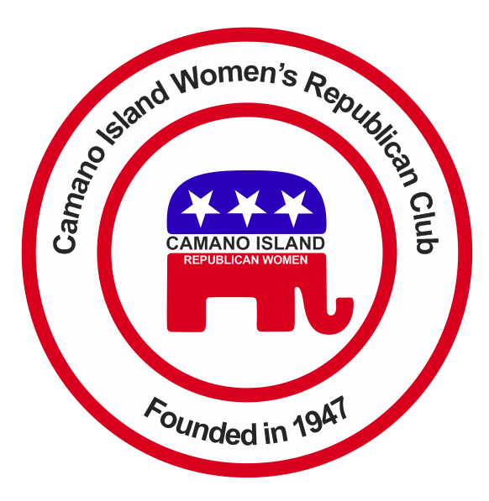
March 2016
Contact: Cindy Stulken 940-230-1525 E-mail: cstulken@hotmail.com
NEXT MEETING: Tuesday, March 29, 6:00PM
PLACE: Camano Library, Camano Island, WA 98282
Program: Bill Bryant Republican Candidate for Govenor
In The News  Super Tuesday Results:  Trump – 7 states, 237 delegates  Cruz – 3 states, 209 delegates  Rubio – 1 state, 9 delegates  Upcoming Primaries:  3/5 – KS, KY, LA & ME  3/8 – HI, ID, MI, MS  3/12 – Washington DC  3/15 – FL, Il, MO, NC, OH  3/22 – AZ, UT  February Recap  *2016 Programs and Bylaws and Budget approved by members.  *Great presentation by Commander Donald Leingang from USO. Support the USO Patriot Wall Buy a brick - $250, $450, $475 and help support a great organization.  *Thank you Virginia Collins for keeping us informed on Supreme Court US v. TX on Immigration.  *If you haven’t sign up yet we still need volunteers to work at the Camano Center Women’s Expo, May Tea, Stanwood-Camano Fair, and I-5 Rest stop. | UPCOMING EVENTS  3/13 – Daylight Savings begins  3/17 – Saint Patrick’s Day  3/19 – Port Susan Home & Garden Show at Camano Center 606 Arrowhead Rd.  3/20 – Palm Sunday, First day of Spring  3/25 – Nat’l Medal of Honor Day and Good Friday  3/27 – Easter  3/29 - CIWRC Meeting 6PM at Camano Library – invite your friends and neighbors to meet and greet Bill Bryant.  REMINDERS  *Tickets were passed out to members to sell for the Women’s Expo raffle on April 30th.  *CIWRC will provide a Garden Basket for the raffle. Please bring an item for the basket to the next meeting.  www.wsrp.org - Republican news, events, and candidate information! | March  Key Note Speaker  Bill Bryant  March 29th 6:00 PM (doors open 5:30) Camano Island Library, 848 N Sunrise Blvd.  Refreshments will be served.  New Member Corner!  Carole Jacobs – Retired elementary teacher of 20 years. She has two children and four grandkids. She moved from S. California and has lived on the island for twelve years. She enjoys knitting, working on photo albums and spending time with family. Welcome!  CIWRC WEBSITE  Check it out –www.ciwrc.com
Officers: President –Barbara Vibbert; Vice-President –Paula Deter; Secretary –Lesley Bentley; Treasurer – Linda Navarre; Trustee – Sally Sample; Trustee – Linda Hoggarth

