CIWRC NEWS
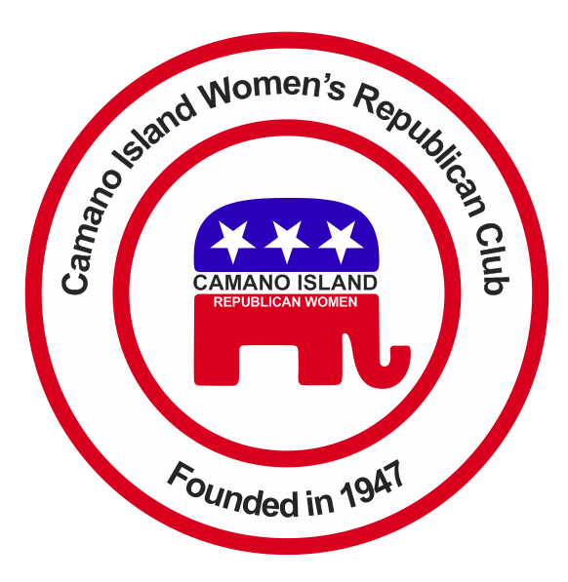
JANUARY 2016
Contact: Barbara Vibbert 360-629-0399 E-mail: jabvibbert@gmail.com
NEXT MEETING: Tuesday, January 26, 2015 at Noon
PLACE: Lost Lake Clubhouse, 1469 Lake Drive, Camano Island, WA 98282
PROGRAM: WORKSHOP – About Caucusing by Mike Navarre
HAPPY NEW YEAR!!  We’ve had a busy and productive 2015 – new members joined, new traditions set, and fundraising increased our coffers allowing us to further pursue our goals. THANK YOU ALL!!  AT THE CHRISTMAS PARTY  2016 CIWRC Officers were installed by NW District Director, Jeanne Quinlivan and Cristi Lysne, WFRW Coordinator of District Directors, presented the NFRW Achievement Award to the Club at the December 8 party. Everyone enjoyed the great food, fun drawings, and lively music played by Camano violinist, Walt Werme and guitarist, Ken Mathias. The Club donated 12 bags of food to the Stanwood-Camano food banks as well as hundreds of signed Christmas cards to vets at the Madigan hospital.  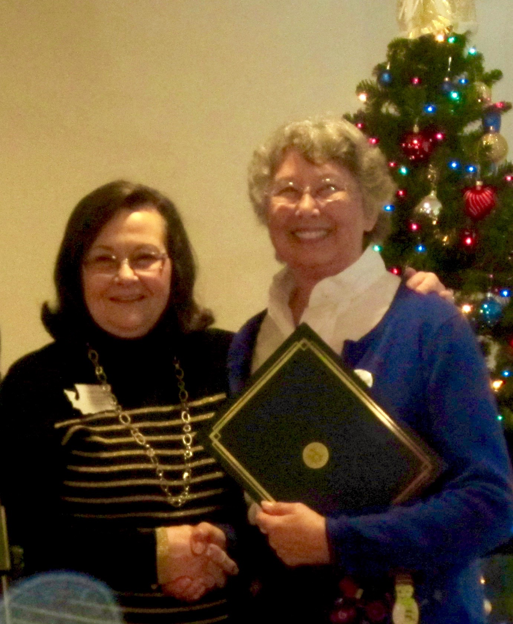 | UPCOMING EVENTS  WFRW Day at the Capitol – Friday, February 12 – You are invited to meet & greet your state legislators at this annual event in Olympia. Reservations are $4.50 if you bring your own lunch or $18.50 which includes the box lunch provided. If you want to go, mail your check, payable to Thurston County Women’s Republican Club, along with your choice for lunch, to Barbara Vibbert, no later than January 20. We will go as a group and carpool.  Republican Precinct Caucuses -Saturday, February 20, 10 a.m. to elect delegates and alternates to the county convention or legislative district caucus and discuss issues pertinent to the Republican platforms for county, state, and national organizations. Mike Navarre will present information on caucusing for the 10th Legislative District at the CIWRC January meeting workshop.  Lincoln Day Dinner- March 12 at 5 p.m., Oak Harbor. | JANUARY WORKSHOP  Put on your thinking caps! We’ll be going over the Proposed Calendar of Events and Budget for the upcoming year. Of special importance is the introduction of new Bylaws for our Club covering changes required by WFRW and NFRW. For example, adding a Budget & Finance Committee, changing the term of office to one year, and the addition of a section on communications. Sign-up sheets will also be available for volunteers to work at the Camano Center Women’s Expo, May Tea, Stanwood-Camano Fair, and I-5 Reststop. See you there!!  IDEAS FOR PROGRAMS, SPEAKERS, and SCHOLARSHIIP CANDIDATES WANTED!!  If you would like to have a particular speaker or event at future meetings or have a candidate for scholarships, let the Executive Board know.  CIWRC WEBSITE  Check it out –www.ciwrc.com
Officers: President –Barbara Vibbert; Vice-President –Paula Deter; Secretary –Lesley Bentley; Treasurer – Linda Navarre; Trustee – Sally Sample; Trustee – Linda Hoggarth

