CIWRC NEWS
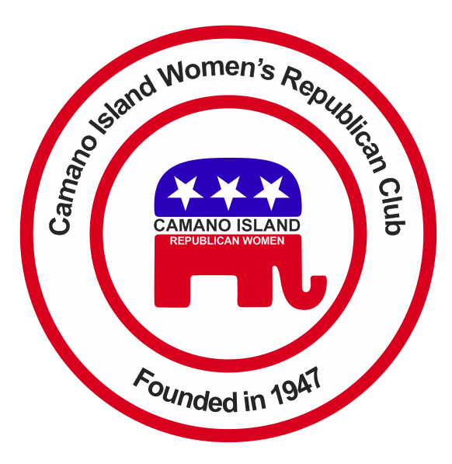
January 2015
Contact: Barbara Vibbert 360-629-0399 E-mail: jabvibbert@gmail.com
NEXT MEETING: Tuesday, January 27 at Noon
PLACE: Lost Lake Club House, 1469 Lake Drive, Camano Island, WA
PROGRAM: Leadership Workshop
WELCOME !!  A big 2015 Welcome to all of you new and returning members. For those of you who haven’t met her, say hello to Iris Green who joined us at the Christmas Party. We now have 24 solid members and three Associates. Let’s keep those numbers moving up!  We have an exciting agenda for 2015 with lots to look forward to: Interesting and educational speakers, such as the Island and Snohomish County Chairs talk on the Differences Between Republicans and Democrats; an update on Common Core; a May Tea Fundraiser; a Potluck Picnic at the beach with Rep. Dave Hayes; and a Holiday Bazaar & Bale Sale in November. Don’t throw away your unused Christmas or other holiday decorations - give them to Linda Navarre or Sally Sample - we can use them to create bazaar items!  ******  G for Growth  O for Opportunity  P for Prosperity | Coming Events  LEADERSHIP WORKSHOP  January 27 Meeting  Eileen Sobjack, NFRW Secretary and Past WFRW President, will give pointers in leadership to all our members, especially our new officers and committee chairs. We’ll receive training in duties and responsibilities as outlined in our Bylaws and the NFRW Leader’s Guide. We are all leaders or leaders-to-be so make it a point to be there! The more we know the better our Club can function.  ***  WFRW DAY AT THE CAPITOL  Monday, February 9  You are invited to attend this fun event in Olympia. It’s a great chance to meet & greet your state legislators as well as hear what’s happening at the Capitol. If you want to go call Barbara Vibbert for more details asap so our Club can get registered before the January 29 deadline.  ********  The 2015 Member Handbook is now available. It includes contact info for WFRW, NFRW and our website address, as well as hostess responsibilities. | ACHIEVEMENT AWARD UPDATE  Our Club has made great progress to date but we still have a ways to go to qualify for an NFRW Award. Some of the things we need to accomplish this year include attending conventions, establishing a scholarship for a needful Republican woman in our area, support for military troops, studying and acting on upcoming or current legislation, and developing an essay contest to promote Americanism in our schools.  ** Let’s hear your ideas! **  If you know of a Teenage Republican Group in our area or a Republican woman who may need help with college tuition, please let the Board know.  QUILTS FOR VETS  We are collecting COTTON fabric pieces for quilts which we will donate to American Hero Quilts – Stanwood Senior Center. Fabrics should be of good quality, washed and ironed, and red, white, and blue in color. Bring whatever you can to the next meeting.

Officers: President –Barbara Vibbert; Vice-President –Evelyn Biehl; Secretary –Paula Deter; Treasurer- Linda Navarre; Trustee- Sally Sample; Trustee – Linda Hoggarth

