CIWRC NEWS
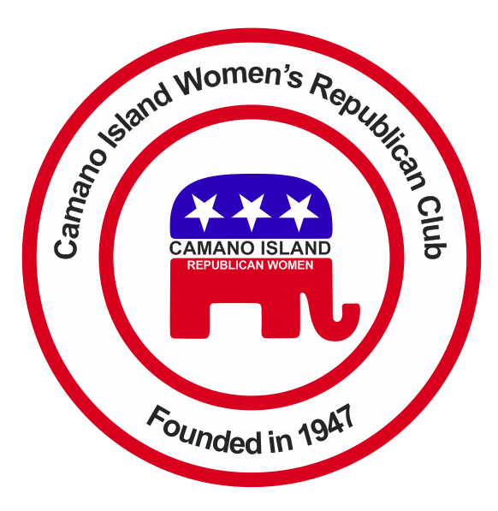
April 2016
Contact: Cindy Stulken 940-230-1525 E-mail: cstulken@hotmail.com
NEXT MEETING: Tuesday, April 26, 2016, at noon
PLACE: Lost Lake Clubhouse, 1469 Lake Drive, Camano Island, WA 98282
Program: Dr. Roger Stark
In The News  Delegate count as of 3/29/16  Trump – 736  Cruz – 463  Kasich – 143  The next major Republican primary is April 5 in Wisconsin. New York is April 19th, and April 26th in Connecticut, Delaware, Pennsylvania, Maryland and Rhode Island.  March Recap  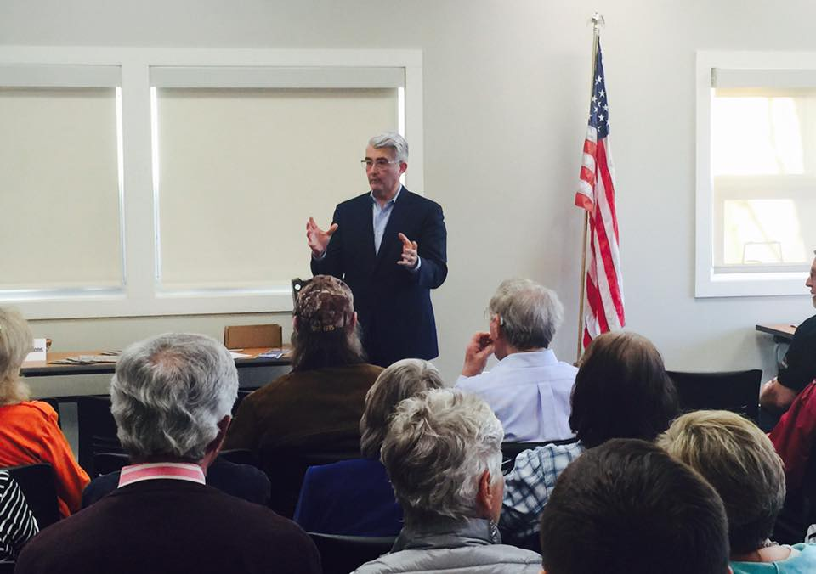  *We had a full house at Camano Island library on the 29th. Bill Bryant’s leadership is good for Washington. He believes in cutting taxes, keeping jobs in the state, reducing traffic congestion, implementing a zero based budget initiative that will examine the effectiveness of every program and tax incentive. He knows how to build coalitions and pull people together to prioritize what’s best for Washingtonians. www.billbryantforgovernor.com/about | UPCOMING EVENTS  4/26 – CIWRC meeting  4/30 – 2016 Women’s Expo  REMINDERS  *Tickets were passed out to members to sell for the Women’s Expo raffle on April 30th.  *CIWRC will provide a Garden Basket for the raffle at the Women’s Expo. Please bring an item for the basket to the next meeting. Tickets are $1 each or 6 for $5.  Mother-Daughter Tea –Saturday May 7th from Noon – 2:00PM. Adult tickets $10, ages 6-12 $5. Our guest is Masaye Nakagawa, Master of the Japanese Tea. Call 360-629-0399 for tickets.  GOP HQ - Stanwood office: The office will open April 21st. It will be open on Thursday, Fridays, and Saturdays. Each shifts will be three hours; 10:00 AM – 1:00 PM, 1:00-4:00 PM and 4:00-7:00 PM. Volunteers are needed to work. A signup sheet will be at the next meeting. If you can work prior to the meeting call Beth Munson. | April  Speaker  Dr. Roger Stark  Dr. Roger Stark is a health care policy analyst at Washington Policy Center and a retired physician. He currently serves on the Board of the Washington Liability Reform Coalition.  "Watch for our Club in the NFRW spotlight". If everyone isn't getting the NFRW weekly news or Roundtable by e-mail, sign up for it at membership@nfrw.org  CIWRC WEBSITE  Check it out –www.ciwrc.com  For Republican news, events,  and candidate information!  www.islandcountygop.com  www.wsrp.org
Officers: President –Barbara Vibbert; Vice-President –Paula Deter; Secretary –Lesley Bentley; Treasurer – Linda Navarre; Trustee – Sally Sample; Trustee – Linda Hoggarth

