CIWRC NEWS
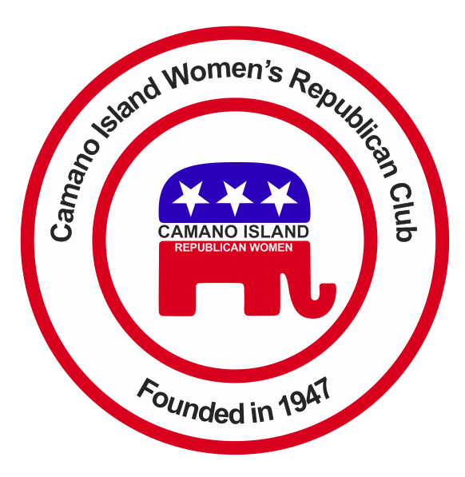
JULY-AUGUST 2015
Contact: Barbara Vibbert 360-629-0399 E-mail: jabvibbert@gmail.com
NEXT MEETING: Tuesday, September 22 at Noon
PLACE: Lost Lake Clubhouse, 1469 Lake Drive, Camano Island, WA 98282
PROGRAM: Camano Island Librarian David Menard
JUNE POTLUCK PICNIC  Rep. Dave Hayes and Camano Fire Chief, Michael Schick joined us for the potluck at Country Club Beach #2. Rep. Hayes gave an update on current legislative issues and Chief Schick talked about station programs available to Camano Island. A fun time was had by all – great food, good conversation, and lots of prizes – thanks to Linda Hoggarth, Linda Navarre, Paula Deter, and their helpers.  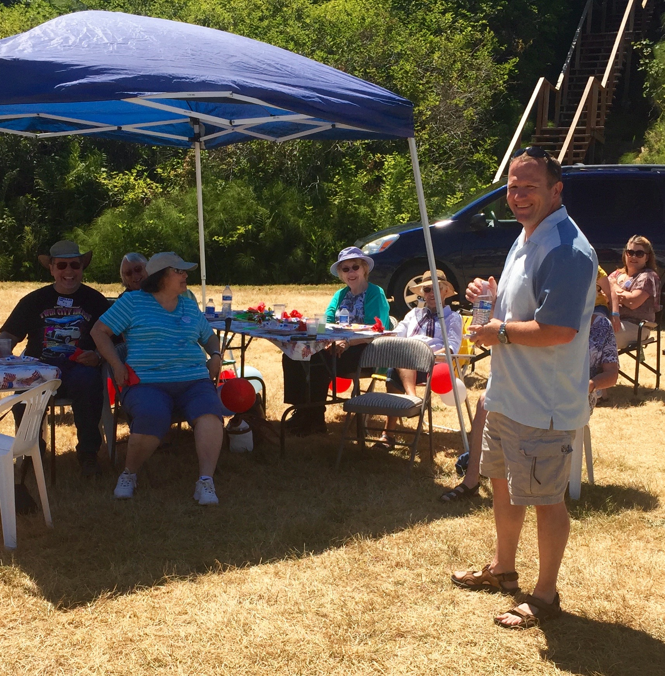  Educate Yourself and Your Legislators !!  Legislative hotline:  800-562-6000  Let your voice be heard! | Coming Events  STANWOOD-CAMANO FAIR  There is still time to help out at the CIWRC fair booth and get a free pass for the day. If you can sit at Booth #40 on Saturday, August 1 from 9 a.m. – 1 pm. or 1 p.m. – 5 p.m. to give out handouts and greet the public please let Beth Munson (387-3877) or Barbara Vibbert (629-0399) know. The fair runs from July 31 thru August 2 so come on out and see what the “best li’l fair in the west has to offer!  ELECTION OF OFFICERS  CIWRC needs YOU !! To continue as a viable club we need new members and willing volunteers to serve as officers on the Executive Board and committees. Three (3) members are needed immediately to serve on a Nominating Committee to find and present a slate of officers for 2016 at the September meeting. Terms of office are for one year. If you are willing to serve on this committee, please call Barbara Vibbert asap.  LITERACY MONTH  September is NFRW Literacy Month. Rep. Dave Hayes and Beth Munson have agreed to present booklets on a “Student Guide to the Legislature” to Stanwood High School students in September on behalf of CIWRC. | I-5 RESTSTOP  COFFEE STAND  A big thank you to Jacie DeGroot for organizing the 3-day coffee stand fundraiser at the I-5 northbound reststop. Despite a mid-week timeframe and little traffic during the wee hours of the night, we had a reasonable showing with about $480 in donations. This will be up for discussion at the September meeting.  4th of JULY PARADE  Paula Deter reported several members showed up to walk the parade and give out flags. Her son, Robert, drove “big white” with banners followed by supporters for Republican Norm Nunnally, candidate for SnoCo Executive. Thumbs up, Paula!!  CIWRC WEBSITE  Check it out –www.ciwrc.com

Officers: President –Barbara Vibbert; Vice-President –Evelyn Biehl; Secretary –Paula Deter; Treasurer – Linda Navarre; Trustee – Sally Sample; Trustee – Linda Hoggarth

