CIWRC NEWS
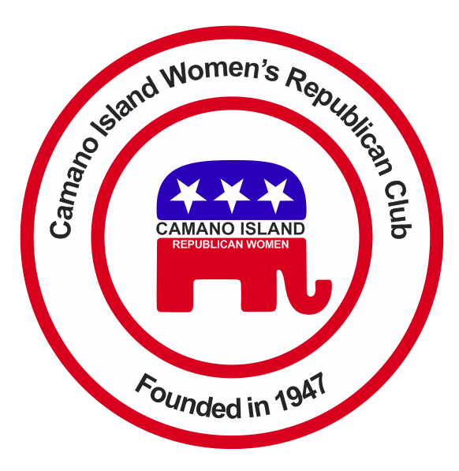
February 2016
Contact: Cindy Stulken 940-230-1525 E-mail: cstulken@hotmail.com
NEXT MEETING: Tuesday, February23, 2015 at Noon
PLACE: Lost Lake Clubhouse, 1469 Lake Drive, Camano Island, WA 98282
Program: Guest Speaker CDR Donald M. Leingang
In The News  Iowa Caucus – Cruz (won) 27.6%  New Hampshire Primary – Trump 35%  CNN Debates Feb 26 and Mar 10th  January Recap  *Our group is growing, we welcomed a new member this month; Carol Jacobs.  *A big thank you to Mike Navarre for explaining how caucuses for the 10th Legislative District works.  * There are many events this year, if you missed January’s meeting volunteers are still needed to work at the Camano Center Women’s Expo, May Tea, Stanwood-Camano Fair, and I-5 Rest stop.  WFRW Day at the Capitol – Friday, February 12 – Nine members traveled to Olympia to meet and listen to state legislators. We heard from over fourteen legislators and at least seven senators. We also heard from Bill Bryant who will speak to us in March, so mark your calendar and invite your friends!  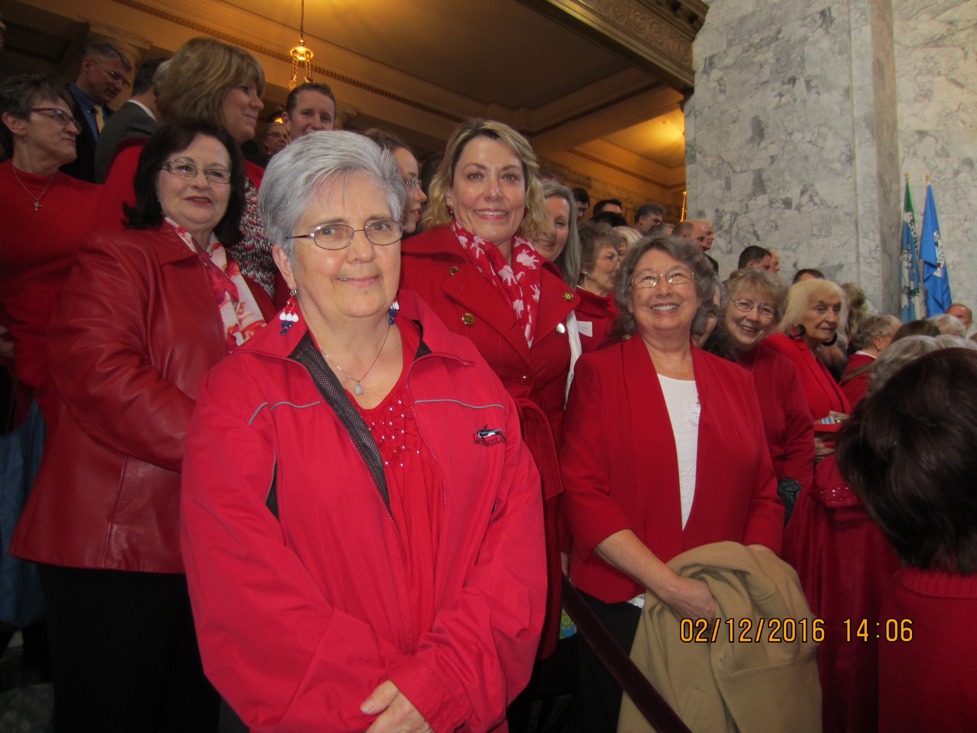 | UPCOMING EVENTS  Feb 15th – President Day  “It is impossible to rightly govern a nation without God and the Bible” George Washington  Feb 18th 6-7pm Rep. Dave Hayes 10th District telephone town hall meeting: (360) 553-3090  WA Republican Precinct Caucuses -Saturday, February 20, 10 a.m. to elect delegates and alternates to the county convention or legislative district caucus and discuss issues pertinent to the Republican platforms for county, state, and national organizations. Starts at 9:30 AM at Utsalady Elementary School, 608 Arrowhead Rd. Register for caucus at:  http://www.islandcountygop.com/  Bill Bryant – March 29 at 7 PM Republican candidate for Governor of Washington state.  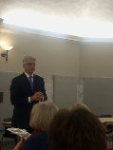 | February WORKSHOP  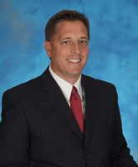  Please welcome Commander Donald Leingang a northwest native who retired in 2008 as Executive Officer at the Naval Station in Everett. He had a distinguished 24-year Naval career that included many leadership positions. He is serving as USO Executive Director of the Puget Sound Area.  Virginia Collins will report on Supreme Court case US v. Texas on Immigration. The case deals with suing the Obama administration for executive overreach.  Cindy Stulken – New editor of Newsletter. I moved to Camano June 2014. I have twenty years experience in financial industry and 10 years in education. My husband and I have four kids and five grandkids. I volunteer with special need kids at SHS. I love gardening, sewing and spending time with grandkids.  CIWRC WEBSITE  Check it out –www.ciwrc.com
Officers: President –Barbara Vibbert; Vice-President –Paula Deter; Secretary –Lesley Bentley; Treasurer – Linda Navarre; Trustee – Sally Sample; Trustee – Linda Hoggarth

