CIWRC NEWS
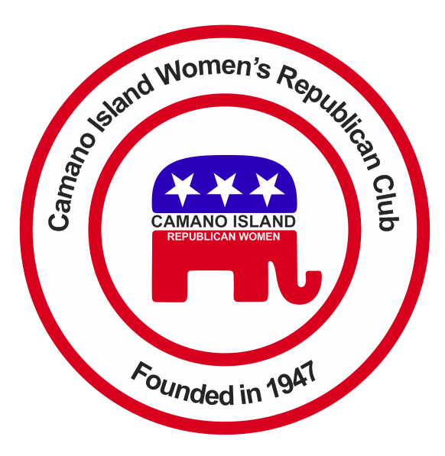
SEPTEMBER 2015
Contact: Barbara Vibbert 360-629-0399 E-mail: jabvibbert@gmail.com
NEXT MEETING: Tuesday, September 22 at Noon
PLACE: Lost Lake Clubhouse, 1469 Lake Drive, Camano Island, WA 98282
PROGRAM: Camano Island Library Manager, David Menard
GOP DEBATE  The next GOP Debate from the Ronald Reagan Presidential Library, Simi Valley, CA will be held on September 16 at 5:00 p.m. local time on CNN.  Be sure to watch your favorite candidate square off with the rest of the lineup at home or at the Historic Everett Theatre event hosted by the Evergreen and Snohomish County Republican Women’s Clubs. Contact Debbie Blodgett by e-mail for tickets: debrablodgett930@msn.com. Admission is $10. Box lunch $5. David Boze Commentator.  MEMBER SURVEY  Are you satisfied with the direction the Club has taken following national guidelines? Are you willing to serve on the Board and committees? Should the Club have evening meetings? Change location? Take the survey at our September meeting and let the Board know what’s on your mind! | Coming Events  ELECTION OF OFFICERS  CIWRC needs YOU !! To continue as a viable club we need new members and willing volunteers to serve as officers and chair committees. The Nominating Committee – Linda Navarre, Beth Munson and Sandy Gaines currently has a slate of officers for the October 2016 election to present at the September meeting, however, chair positions for Publicity, Scholarship, Sunshine, and Audit committees are still open. If you would like to chair or be on any of these committees, please contact Barbara Vibbert.  LITERACY MONTH  September is NFRW Literacy Month. Rep. Dave Hayes and Beth Munson have agreed to present booklets on a “Student Guide to the Legislature” to Stanwood High School students in September on behalf of CIWRC.  HOLIDAY BAZAAR & BAKE SALE  Mark your calendar for the Club bazaar on Saturday, November 7  If you have items to donate to the bazaar please contact Linda Navarre, 387-5886  Linda will have a sign-up sheet and more info at this month’s meeting. | DUES ARE DUE!!  Annual dues are $30 for regular CIWRC membership and $20 for associates to be paid by the end of October for 2016.  WFRW FALL CONFERENCE  The 2015 Fall Board Meeting/Conference will be held at the Doubletree Suites, 16500 Southcenter Pkwy, Seattle, WA Friday & Saturday, November 13-14. If you would like to attend please let Barbara Vibbert know asap. Hotel rates for Club members are $99 plus tax.  CIWRC WEBSITE  Check it out –www.ciwrc.com  Educate Yourself and Your Legislators !!  Legislative hotline:  800-562-6000  Let your voice be heard!

Officers: President –Barbara Vibbert; Vice-President –Evelyn Biehl; Secretary –Paula Deter; Treasurer – Linda Navarre; Trustee – Sally Sample; Trustee – Linda Hoggarth

