CIWRC NEWS
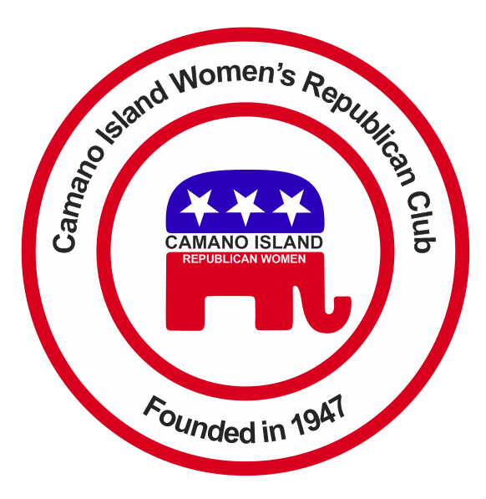
April 2015
Contact: Barbara Vibbert 360-629-0399 E-mail: jabvibbert@gmail.com

NEXT MEETING: Tuesday, April 28 at Noon
PLACE: Lost Lake Club House, 1469 Lake Drive, Camano Island, WA
PROGRAM: Update on Common Core with Sharon Hanek (WFRW )

*** SUPPORT OUR TROOPS ***  Caring for America  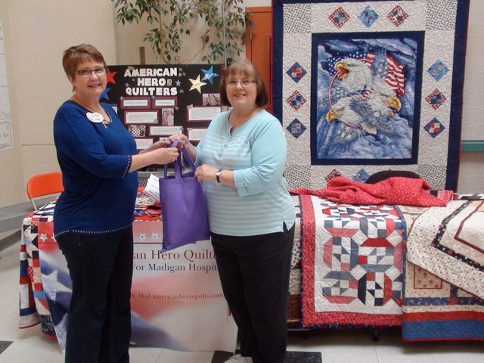  Sandy Gaines and Paula Deter (not shown), Caring for America Committee, donated quilting material gathered by members to Sharon Szekely, American Hero Quilt Group at the Stanwood Quilt Show this month. Each heirloom quality quilt is a “hug” of appreciation for each of our injured troops returning home from war through Madigan Army Medical hospital and other military hospitals.  National Day of Prayer  You are invited to participate in the Thursday, May 7th National Day of Prayer from 12 noon – 1 p.m. at the Stanwood Haggen parking lot. Join many others praying for our nation.  *****  CIWRC WEBSITE  Check it out – www.ciwrc.com | Coming Events  Come on out and join the fun at the 2015 Women’s Expo at the Camano Community Center on Saturday, May 2 from 10 am – 4 pm. This is part of our annual fundraiser so buy or sell lots of tickets for the Date Nite Basket filled with a $75 dinner gift certificate and more!  TURN IN YOUR TICKET STUBS  at the April meeting or bring to Lesley Bentley, our Expo Chair, at the Camano Center by noon on Saturday. Lesley can be reached at 360-572-4244 or E-mail: lesleyanne.luning@gmail.com  ****************  PUT ON YOUR FANCY HAT, bring your daughters, sisters, aunts, nieces and friends to the CIWRC Mother-Daughter Tea from noon – 2 p.m. at the Lost Lake Clubhouse on Saturday, May 9. Sen. Bailey, Reps. Smith & Scott, and WFRW President, Roxanne Husmann are guest speakers followed by the Hat Lady, Kathy Close who will present “A Woman’s Life in Hats”. Tickets for this event - $5 (ages 6-12) and $10 (over 12) will be available at the April meeting and at the door.  If you’d like to help with the tea call Chair, Linda Hoggarth – 425-344-7419. | Sharon Hanek (Research Mom)  Sharon grew up on US military bases in Japan, moved to Washington, earned a BA in Business Admin & Accounting from the University of of Washington and became a CPA. She used her extensive volunteer experience to form a public policy research company.  She is best known by Republican Women groups for her work to stop Common Core.  You can find out more by going to her website:  researchmom.org.  ******************  Educate Yourself and Your Legislators !!  Legislative hotline:  800-562-6000  *****************  G for Growth  O for Opportunity  P for Prosperity

Officers: President –Barbara Vibbert; Vice-President –Evelyn Biehl; Secretary –Paula Deter; Treasurer – Linda Navarre; Trustee – Sally Sample; Trustee – Linda Hoggarth

