CIWRC NEWS
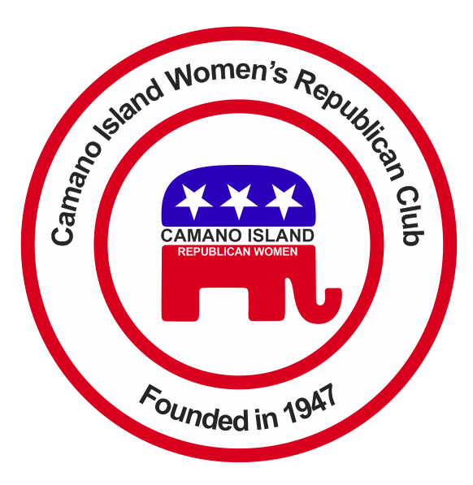
February 2015
Contact: Barbara Vibbert 360-629-0399 E-mail: jabvibbert@gmail.com
NEXT MEETING: Tuesday, February 24 at Noon
PLACE: Lost Lake Club House, 1469 Lake Drive, Camano Island, WA
PROGRAM: Basic Campaign Planning – Anne Marie Gurney, Freedom Foundation
WFRW Day at the Capitol  On February 9, Barbara Vibbert joined members from every club in the state for the WFRW day in Olympia. Our legislators, Rep. Dave Hayes and Sen. Barbara Bailey and legislators from other districts spoke to over 200 women on current issues.  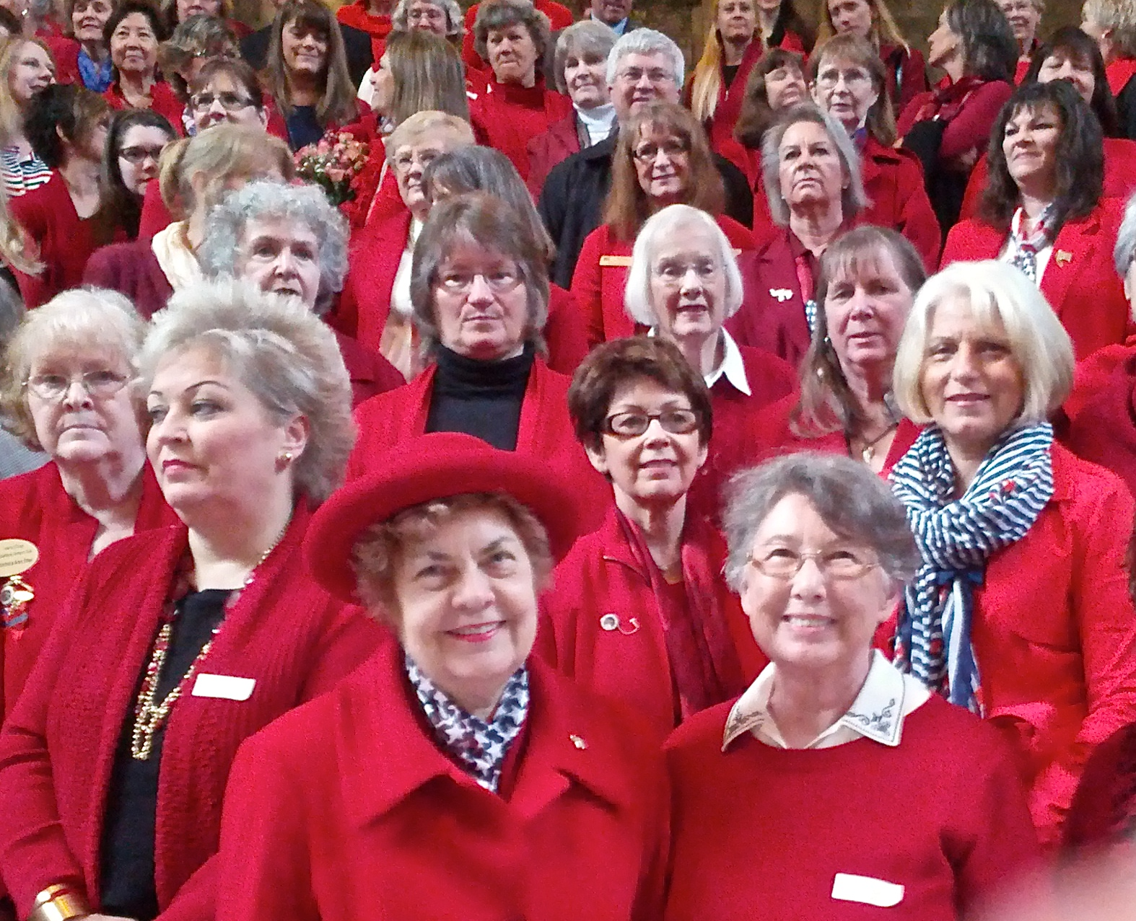  Education was a hot topic – especially Common Core (CC). What you should know:  CC has a one size fits all approach; it’s subject to data mining and tracking via assessments; parents and school boards are no longer in the driver’s seat; CC was created by private special interest groups contrary to state sovereignty and the U.S. Constitution; and taxpayers are on the hook for implementation costs and infrastructure for new technology.  WHAT YOU CAN DO –Educate yourself and your Legislators – Request Repeal of Common Core AND SBAC Assessments –  Call the legislative hotline at  800-562-6000  or go to website  www.stopcommoncorewa.wordpress.com | Coming Events  Don’t miss this month’s meeting with Anne Marie Gurney from the Freedom Foundation who will give us a primer on Basic Campaign Planning. There are 3 Board of Director positions up for election in the Stanwood School District this year as well as Camano Vista Water Commissioner Pos. 3.  Learn how to campaign for your candidate. Invite your friends and neighbors!!  Take a look at the Budget and Proposed Calendar of Events handed out at the last meeting and prepare to vote on them on the 24th.  At the March Meeting GOP Chairs, Sandi Peterson and Billye-Brooks-Sebastiani will present the differences between Republicans and Democrats.  The Island County Lincoln Day Dinner is scheduled for the evening of April 17. Details pending. | BREAKING NEWS!  Mellissa Pilolla and Tim Loney replace John Foules as the new 10th District GOP Co-Chairs  There is great concern among Republican Women about human trafficking. NFRW adopted a resolution in 2014 calling for “every state to enact stringent legislation against human trafficking, with strict minimum sentences, incarceration and asset confiscation for the criminals perpetrating human trafficking.”  You can help by writing and/or calling your state and federal representatives – let them know how you feel about this most egregious crime.  ***********************  G for Growth  O for Opportunity  P for Prosperity

Officers: President –Barbara Vibbert; Vice-President –Evelyn Biehl; Secretary –Paula Deter; Treasurer – Linda Navarre; Trustee – Sally Sample; Trustee – Linda Hoggarth

