CIWRC NEWS
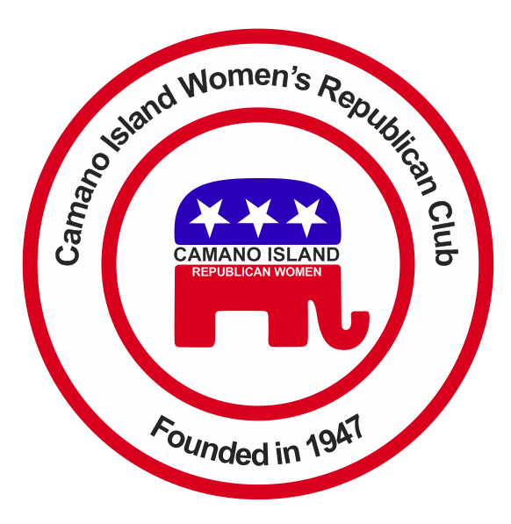
March 2015
Contact: Barbara Vibbert 360-629-0399 E-mail: jabvibbert@gmail.com
NEXT MEETING: Tuesday, March 24 at Noon
PLACE: Lost Lake Club House, 1469 Lake Drive, Camano Island, WA
PROGRAM: Differences Between Republicans and Democrats – GOP Chairs
It’s History Month  Here’s Your Chance to Make History!!  Put a Woman on the $20 Bill!  “Women on 20s” hopes to generate a mandate for a new $20 bill to be issued in 2020 to commemorate the 100th anniversary of the constitutional amendment giving women the right to vote. To learn more Go to: womenon20s.org. Many of the candidates “lean to the left”, including such well-known figures as Eleanor Roosevelt and Susan B. Anthony, but candidates such as women’s rights pioneer Elizabeth Cady Stanton, American Red Cross founder Clara Burton, and Francis Perkins, the first female cabinet member in US history, have a more universal appeal.  Cast your vote today!  Track Legislation and Support  Sen. Barbara Bailey’s upcoming bill addressing those teachers collecting full pension benefits despite being convicted of work related crimes.  WHAT YOU CAN DO –Educate Yourself and Your Legislators !!  Send letters! E-mail! Call!  Legislative hotline: 800-562-6000 | Coming Events  March Meeting - GOP Chairs, Sandi Peterson and Billye-Brooks-Sebastiani will present the differences between Republicans and Democrats as well as present the Republican Party Action Plan. Bring your family, friends and neighbors to this most informative meeting.  The Island County Republican Party Lincoln Day Dinner and Silent Auction will be Friday, April 17 at 6:15 p.m. with speaker Washington Secretary of State, Kim Wyman. Cost $60. For more info go to the link on the CIWRC website or call Sandi Peterson at 360-720-2728.  2015 Women’s Expo at the Camano Community Center on May 2. If you’d like to spend a couple hours at our table and have a fun time telling people about CIWRC and scoping out the Expo, sign up with Lesley Bentley, our Expo Chair, at the March meeting or call her at 360-572-4244 or E-mail: lesleyanne.luning@gmail.com  Tickets for the “Date Nite” raffle will be available at this meeting. | Wanted  Scholarship Chair  The Scholarship Committee needs a chairperson. If you’re interested in helping set up an essay contest and go to the local High School to give out legislative material this job is for you! Please let the Board know asap if you can do this.  Wanted  Helpers for the CIWRC May 9 Tea. If you’d like to help with the tea call Chair, Linda Hoggarth – 425-344-7419.  Tickets for this event -  $5 (ages 6-12) and $10 (over 12) will be available at the March meeting.  CIWRC WEBSITE  Our website has a new look – thanks to our webmaster, Mike Navarre!! Check it out – www.ciwrc.com  ************************  G for Growth  O for Opportunity  P for Prosperity

Officers: President –Barbara Vibbert; Vice-President –Evelyn Biehl; Secretary –Paula Deter; Treasurer – Linda Navarre; Trustee – Sally Sample; Trustee – Linda Hoggarth

